Wine Regions Research

Wine Regions
With the exception of Lower Orange River and Douglas in the Northern Cape, nearly all South African wine comes from the Western Cape.
The Coastal Region has a hot climate making it an ideal place for bold red wines including Cabernet, Pinotage, and Syrah. There are several cooler microclimates too, producing lush styles of Chardonnay and Sémillon. Highlights include wines from the regions of Stellenbosch, Paarl, and Swartland.
Breede and Olifants River Valleys are still very much considered the value wine areas of the country. You’ll also find many thousands of acres of white varieties including Chenin Blanc that are used for brandy production.
Cape South Coast is tiny, but shows some of the highest potential for great quality, cool-climate wines including those of Pinot Noir, Chardonnay and even sparkling wines (from Elgin). The region is very spread out and producers here are very individualized and unique.
As of 2003, South Africa was 17th in terms of area planted with vines, with the country owning 1.5% of the world's grape vineyards with 110,000 hectares (270,000 acres). Yearly production among South Africa's wine regions is usually around 10 million hL (264 million US gallons) which regularly puts the country among the top ten wine producing countries in the world. The majority of wine production in South Africa takes place in the Cape, particularly the south-west corner near the coastal region. The historical heart of South African wine has been the area near the Cape Peninsula and modern-day Cape Town. This area is still of prominence in the industry being home to the major wine regions of Constantia, Stellenbosch and Paarl. Today, wine is grown throughout the Western Cape and in parts of the Northern Cape, KwaZulu-Natal and Eastern Cape regions. The river regions along the Breede Valley, Olifants and Orange Rivers are among the warmest areas and are often the location of bulk wine production and distillation. The cooler climate regions east of Cape Town along the Indian Ocean coast, such as Walker Bay and Elgin, have seen vast expansion and development in recent years as producers experiment with cool climate varietals and wine styles.
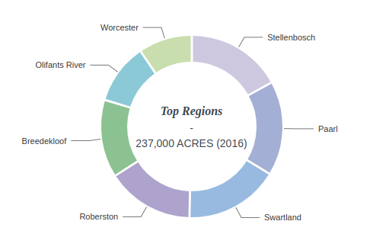

Reference Links

https://en.wikipedia.org/wiki/South_African_wine#:~:text=The%20seven%20wards%20of%20Stellenbosch,%2C%20Merlot%2C%20Pinotage%20and%20Shiraz.

https://winefolly.com/wine-regions/south-africa/

